CS 3365 – Software Engineering I

Homework #6

Luis Rausseo – R11478074

1. For the consolidated communication diagram, merge all communication diagrams into a consolidated communication diagram that shows all objects and their interaction. (4 pts)

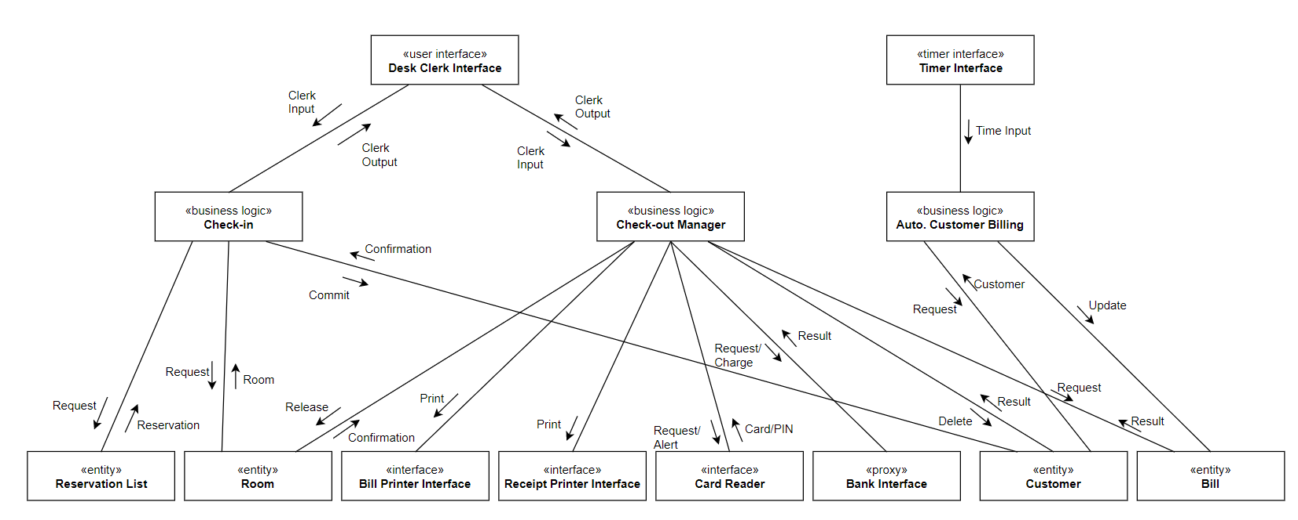

1. Determine the subsystems (or components) of hotel information system and depict them on the consolidated communication diagram. (4 pts)

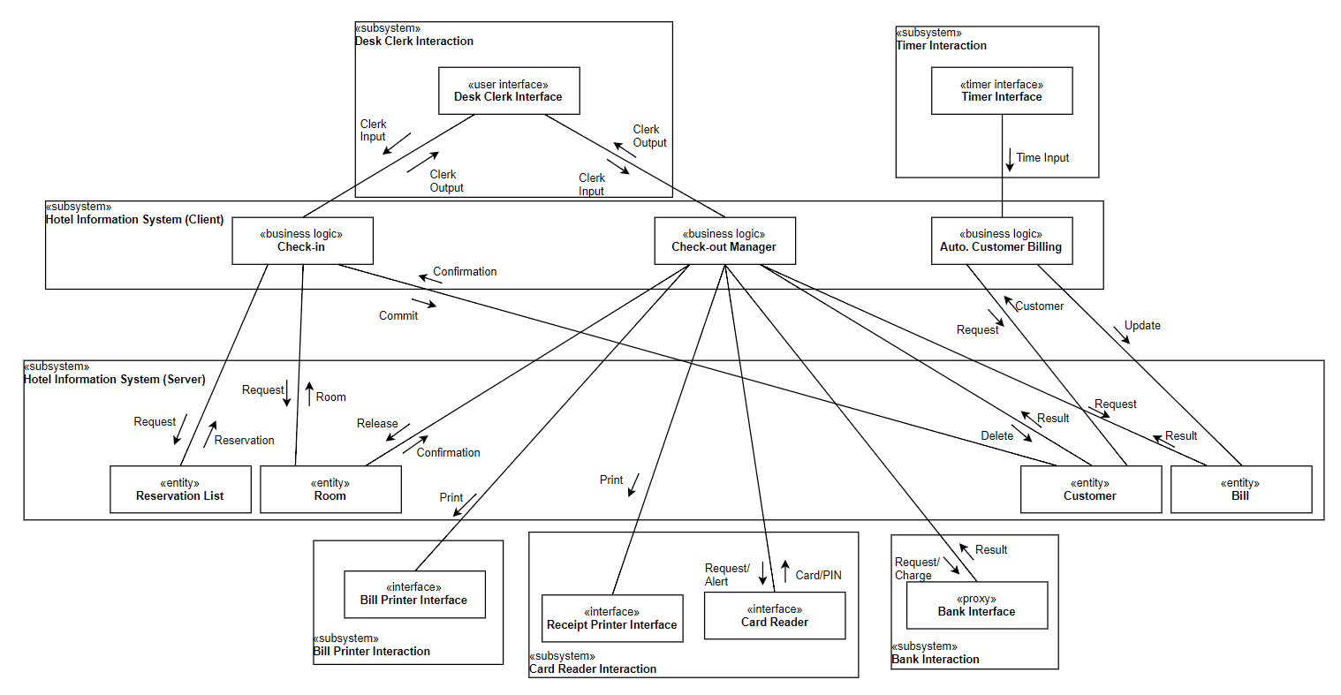

1. Depict function call or message communication for interactions between objects or between subsystems on the consolidated communication diagram. (4 pts)

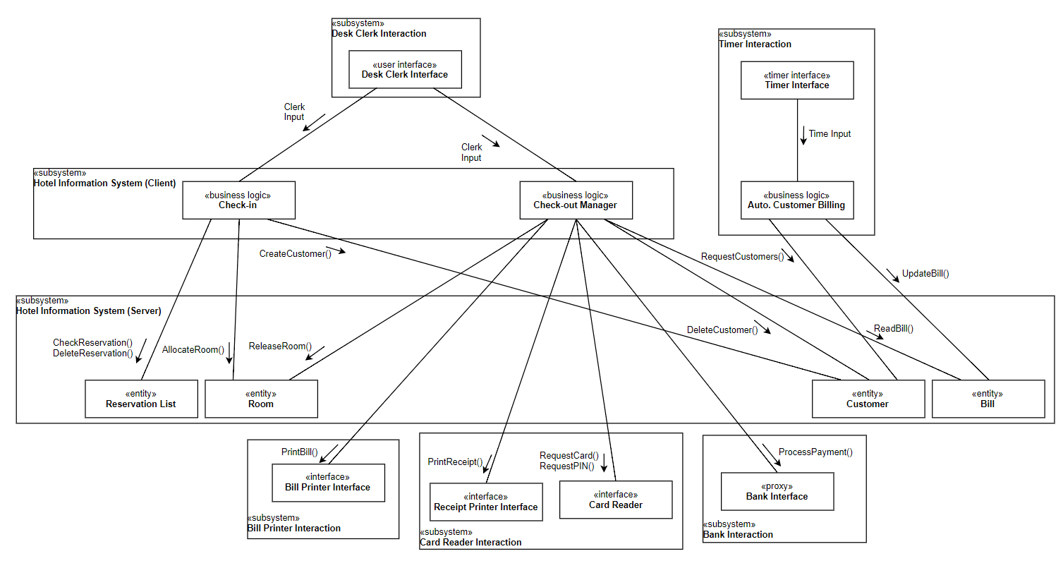

1. Develop the software architecture diagram that shows subsystems and their interaction. (3 pts)

